Hessel Jacobs, Tijn Peters, Kyran Weijman, Kenan Sahin

PRD – Project requirements document
Project group 1

1. About
The goal of this project is to develop an agentic platform that helps our research team create an English-language AI handbook for SMEs such as Waterkracht B.V. The handbook should help SME owners and managers understand what AI can do, where it can create value and what risks and requirements should be considered before implementation.
The platform should support the weekly tasks of student researchers, such as finding sources, checking reliability, processing interviews, summarising information and reviewing the final draft. SME managers should be able to use the handbook to take a practical next step, such as checking whether data is available, comparing AI tools or starting a small pilot. SME managers often play a key role in digitalisation decisions (OECD, 2024).The team aims to publish one new handbook page every week.
2. Market Insights and Users
SMEs increasingly use digital technologies, but they still lag larger firms in AI adoption and often face barriers such as limited skills, data and resources (OECD, 2025). Technical SMEs such as Waterkracht therefore need practical guidance linked to processes such as purchasing, inventory, planning and maintenance.
Relevant information is spread across academic research, government reports, industry sources, competitor websites and interviews. The platform should combine these sources into practical information for SME owners and managers with limited AI expertise.
3. The Problem
Researchers currently search, evaluate, translate and summarise sources manually before turning them into an English handbook page. We assume this process is time-consuming and may lead to differences in output quality. Generative AI has been shown to reduce completion time and improve quality in professional writing tasks (Noy & Zhang, 2023).
Language is another challenge. Many relevant sources about Dutch SMEs are only available in Dutch, which can limit access for non-Dutch-speaking team members (Ramírez-Castañeda, 2020).
4. The Solution and User Journey
The platform should support the complete process from raw source material to a published handbook page.
The researcher starts by entering a topic or research question, such as “How can AI support inventory management in an SME?” The platform then helps find relevant sources and can also process sources that are manually uploaded by the researcher.
The agent can combine research steps such as searching, translating, evaluating and summarising sources in one workflow. It can also adapt when more evidence is needed (Huang et al., 2024). Human review remains necessary because AI can still produce incorrect information (Autio et al., 2024).
The AI agent analyses the information, identifies relevant findings and creates a first English draft. The researcher can then check the original sources, edit the content and decide whether the page is ready for publication. Only after human approval can the page be added to the existing wiki or website.
The basic workflow is:
Research question → source collection → source evaluation → translation → analysis → draft → human review → publication
The platform supports the researcher but does not replace human judgement.
5. Requirements and Output Quality
The platform must support searching, analysing and combining information from multiple sources to create a first handbook draft.
A handbook page should be clear, practical and supported by reliable sources. SME owners or managers will rate each page from 1–5 on clarity, relevance, usefulness and ease of understanding. A page is successful with an average score of at least 4/5 and a clear next step for the user (ISO, 2023).
The final content should explain where AI could be useful, what is needed, what the risks are and what to do next.
No page may be published without human approval.
Dutch source handling
Working with Dutch sources is a core requirement of the platform. The system should automatically recognise when a source is in Dutch and then translate, summarise and evaluate the source in English.
The platform should assess whether the Dutch source is relevant and reliable before using it in the handbook. The original Dutch source must remain available so that researchers can verify the translation and interpretation.
For example:
Dutch source → language detection → English translation → reliability and relevance check → summary → use in handbook
This means that team members do not need to manually translate Dutch sources themselves. Language should therefore not determine which team members are able to perform research.
6. Known Constraints
The platform will use an agent-driven CLI instead of developing all functionality through manual coding. The interface and workflow should therefore remain simple enough for a non-programmer to use.
The project must also reuse the existing wiki and website instead of building new infrastructure.
Every automated step must have a manual fallback option. If automatic source discovery fails, a researcher must be able to add a source manually. If a translation or summary is incorrect, it must be possible to edit it. If automatic publication fails, the approved content should still be publishable manually.
Other challenges include incorrect AI-generated information, poor translations and the handling of confidential company or interview data. Original sources must therefore remain available for verification.
7. Out of Scope
The first version will not build a new website or content management system. It will also not connect directly to Waterkracht's ERP, production or other internal systems.
The platform will not implement AI solutions inside Waterkracht itself. Fully autonomous research and publishing are also outside the scope.
The first version focuses only on supporting:
research → translation → analysis → drafting → review → publishing
8. Open Questions and Assumptions
Some decisions still need to be made during development. It is not yet clear which AI model will be used, how the agent-driven CLI will communicate with the existing wiki and how confidential interview or company information should be stored.
For now, the project assumes that both Dutch and English sources will be used, that one handbook page will be produced each week and that every final page will be reviewed by a human before publication.
It is also assumed that most external research material will be publicly available.

9. Measuring Success
The platform is successful when the research team can consistently produce one reliable and reviewed handbook page per week.
A non-programmer should be able to complete the workflow, Dutch sources should be usable without manual translation, important claims should be traceable to their original source and every page should receive human approval before publication.
The overall goal is to make the research process faster, more consistent and accessible to every team member, while keeping researchers in control of the final handbook content.
Source credibility
To measure the creditbility of the sources, the AAOCC model was chosen. The completed AAOCC assessments will be included in the AI model. For this research, only sources with an AAOCC score above 8 were used. This will ensure that the sources used by our AI model will be credible.
AAOCC
1. Authority: The background and credibility of the author. Does the author have sufficient knowledge and expertise on the subject?
2. Accuracy: The validity of the source. How accurate is the information provided?
3. Objectivity: Are the factual details correct? Is the information independent and unbiased?
4. Currency: How up to date is the article?
5. Coverage: Does the article cover the entire subject, or does it only address part of the topic?
The AAOCC model is a framework designed to assess the credibility of sources. It is based on authority, accuracy, objectivity, currency, and coverage. Each of these criteria is given a score from 1 to 10. The average of these five scores is then calculated, resulting in the final AAOCC score. The higher the score, the more reliable and suitable the source is considered to be.
(Rasmuson, 2026).

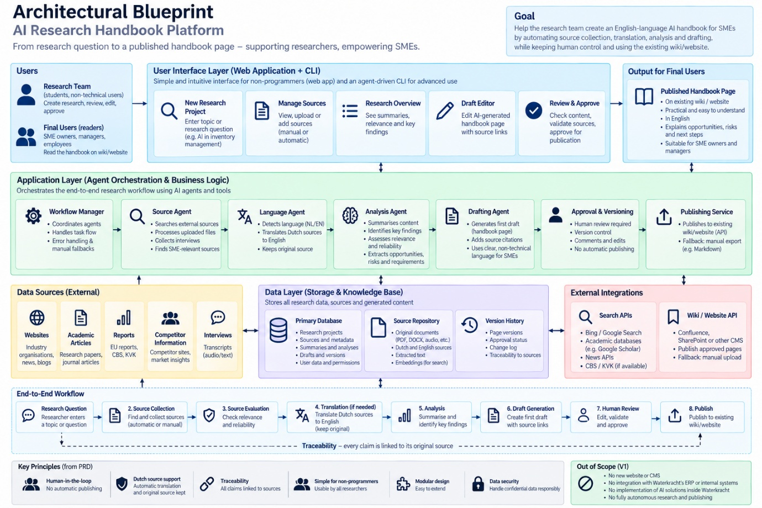

Bibliography
Autio, C., Schwartz, R., Dunietz, J., Jain, S., Stanley, M., Tabassi, E., Hall, P., & Roberts, K. (2024). Artificial Intelligence Risk Management Framework: Generative Artificial Intelligence Profile. National Institute of Standards and Technology. DOI: 10.6028/NIST.AI.600-1.
International Organization for Standardization. (2023). ISO 24495-1:2023 Plain language—Part 1: Governing principles and guidelines. ISO.
Huang, X., Liu, W., Chen, X., Wang, X., Wang, H., Lian, D., Wang, Y., Tang, R., & Chen, E. (2024). Understanding the planning of LLM agents: A survey. arXiv.
OECD. (2024). SME digitalisation to manage shocks and transitions: 2024 OECD D4SME survey. OECD SME and Entrepreneurship Papers, No. 62. OECD Publishing. doi:10.1787/eb4ec9ac-en.
Noy, S., & Zhang, W. (2023). Experimental evidence on the productivity effects of generative artificial intelligence. Science, 381(6654), 187–192. https://doi.org/10.1126/science.adh2586
Ramírez-Castañeda, V. (2020). Disadvantages in preparing and publishing scientific papers caused by the dominance of the English language in science: The case of Colombian researchers in biological sciences. PLOS ONE, 15(9), e0238372. https://doi.org/10.1371/journal.pone.0238372
OECD. (2025). AI adoption by small and medium-sized enterprises: OECD discussion paper for the G7. OECD Publishing. https://doi.org/10.1787/426399c1-en

